Testing levels in UML Design Models

Shanae Revell
The University of Arizona Global Campus
CST499
Charmelia Butler
February 9th 2026

Testing levels in UML Design Models
Testing plays a critical role in verifying that a software system meets its design specifications and functional requirements. After system requirements are translated into UML design models, multiple levels of testing are applied to ensure the system behaves correctly at both the component and system levels. UML diagrams help bridge the gap between requirements and testing by visually representing system structure and behavior, which supports clearer validation and verification activities (Gunik, 2017). For the Online Course Registration System (OCRS), component testing, integration testing, system testing, and acceptance testing are essential to ensuring software quality (Tsui, Karam, & Bernal, 2018).

Component testing, also known as unit testing, focuses on verifying individual software components in isolation. In the OCRS, this includes testing modules such as user login, course availability checks, enrollment processing, and waitlist handling. UML class diagrams support component testing by clearly defining system classes and their responsibilities, making it easier to test each unit independently. Designing components with high cohesion and manageable complexity improves testability and reduces defects at this level (Tsui, 2018).

Integration testing evaluates how individual components interact once they are combined. For the OCRS, this involves testing interactions between modules such as the user interface, course management logic, and enrollment processing. UML sequence diagrams are especially useful during integration testing because they illustrate the flow of messages and data between system components. Lower coupling between components reduces integration risks and makes errors easier to identify and resolve (Sommerville, 2021).

System testing examines the complete system as a whole to verify that all functional and nonfunctional requirements are satisfied. In the OCRS, system testing validates end-to-end scenarios such as logging in, viewing courses by semester, registering for courses, joining waitlists, canceling enrollments, and receiving system notifications. UML activity and state diagrams support system testing by modeling workflows and state transitions, which helps ensure the system behaves correctly under different conditions (Gunik, 2017).

Acceptance testing is the final testing stage and focuses on confirming that the system meets user and stakeholder expectations. This level of testing is guided by the Software Requirements Specification and is typically performed from the user’s perspective. For the OCRS, acceptance testing confirms that students can successfully complete required tasks such as course registration and enrollment management. Completeness and consistency of requirements are especially important at this stage, as missing or conflicting requirements can lead to system rejection or user dissatisfaction (Sommerville, 2021).

In summary, each level of testing builds upon the previous one to ensure overall system quality and reliability. Component and integration testing focus on internal correctness and interactions, while system and acceptance testing validate real-world functionality. Using UML design models alongside sound design principles strengthens the testing process and contributes to a reliable and maintainable software system.
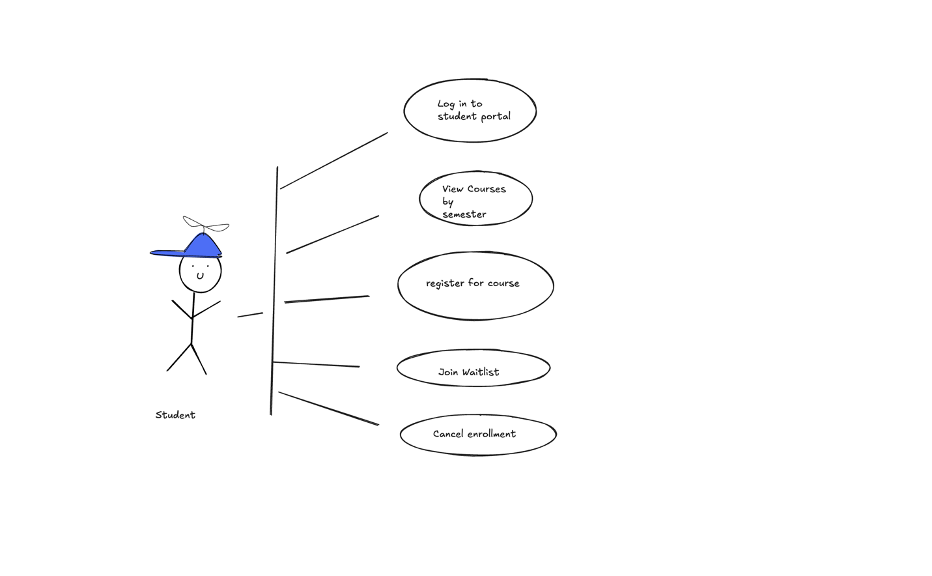
References
Gunik, R. (2017). Facilitating software development using UML models. Contemporary PNG Studies: DWU Research Journal, 27, 52–62.

Sommerville, I. (2021). Engineering software products: An introduction to modern software engineering. Pearson.

Tsui, F., Karam, O., & Bernal, B. (2018). Essentials of software engineering (4th ed.). Jones & Bartlett Learning.

